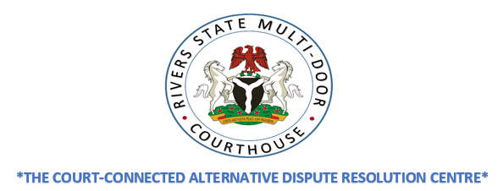

**AN INTRODUCTION TO THE RIVERS STATE MULTI-DOOR COURTHOUSE (RSMDC)**

**The Rivers State Multi-Door Courthouse (RSMDC)** is a Court-connected Alternative Dispute Resolution (ADR) Centre which offers a range of Alternative Dispute Resolution (ADR) processes. The Mission of the RSMDC (also referred to as “the centre”) is to supplement the available resources for justice by providing enhanced, timely, cost effective and user-friendly access to justice. The Multi-Door refers to the various options available at the RSMDC which include Mediation, Arbitration, Early Neutral Evaluation and Hybrid Processes.

The Rivers State Multi-Door Courthouse Bill was passed into Law by the Rivers State House of Assembly on 31st May 2019 as the Rivers State Multi-Door Courthouse Law No. 9 of 2019. The law creates the necessary legal framework for the operations of the RSMDC. It also creates the proper environment for the fulfilment of its overriding objectives. The functions and roles of key justice sector stakeholders have been incorporated into the provisions of the law. The RSMDC is connected to the Rivers State Judiciary and the Citizens’ Mediation Centre of the Rivers State Ministry of Justice. The provisions of the law and Practice Direction 2021 give the Court the power to refer cases to the RSMDC for amicable resolution aimed at improving access to justice using the most appropriate ADR mechanism. It also provides for collaboration between the Citizens’ Rights Directorate of the State Ministry of Justice and the RSDMC.

The RSMDC provides efficient, flexible and impartial administration of ADR proceedings and has access to eminent and experienced arbitrators, mediators and experts with the widest range of expertise in their respective professional fields.

The Management Team of the RSMDC is guided by the Rivers State Multi-Door Courthouse Law in the operation of the Centre. The ADR processes are conducted in line with the RSMDC Mediation/Other ADR Processes & Arbitration Procedure Rules 2021 and the Practice Direction 2021 which are written in plain English for the convenience of all users.

In a bid to ensure cost effective services, the RSMDC administrative charges, and the fees charged by the ADR Experts are minimal and user friendly.

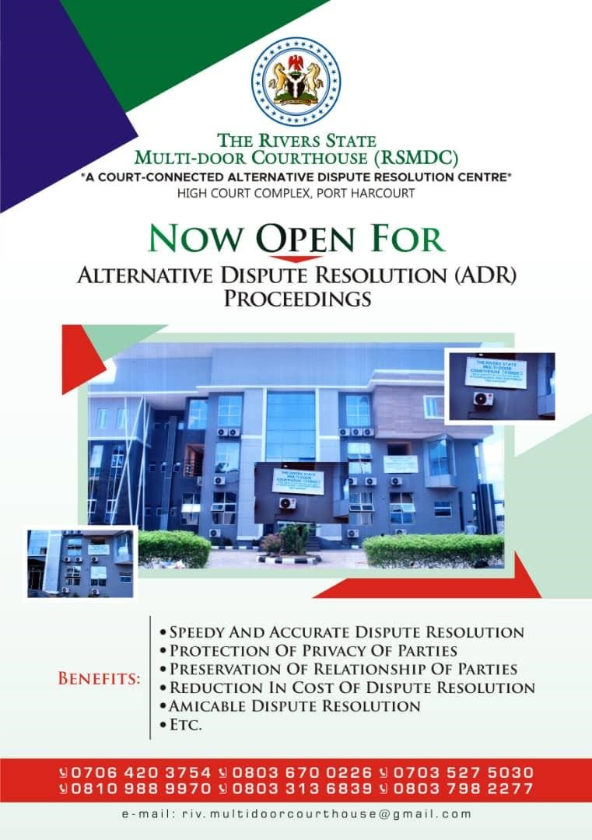

**INITIATING A CASE AT THE RSMDC**

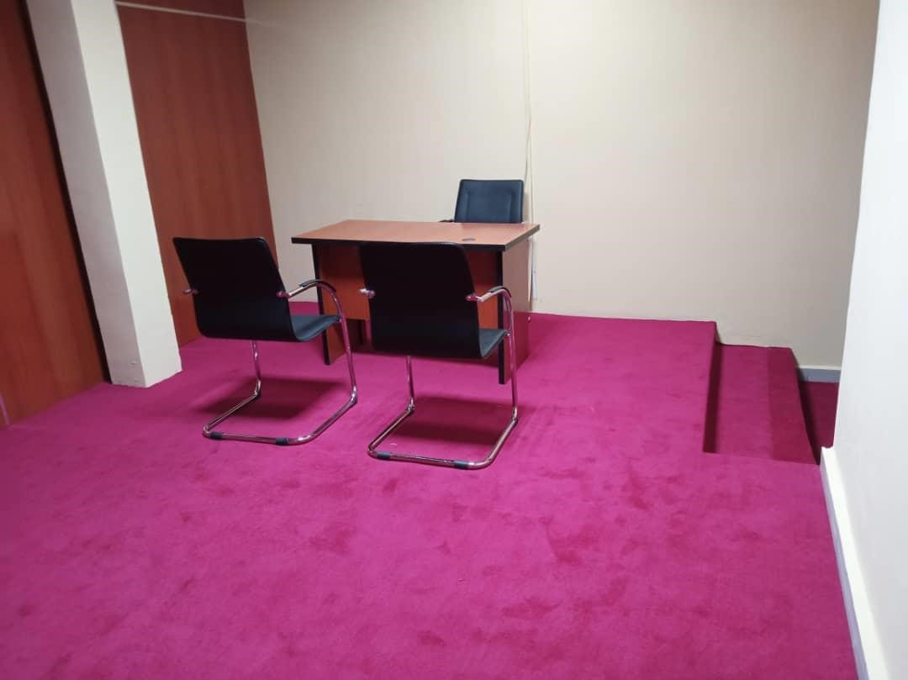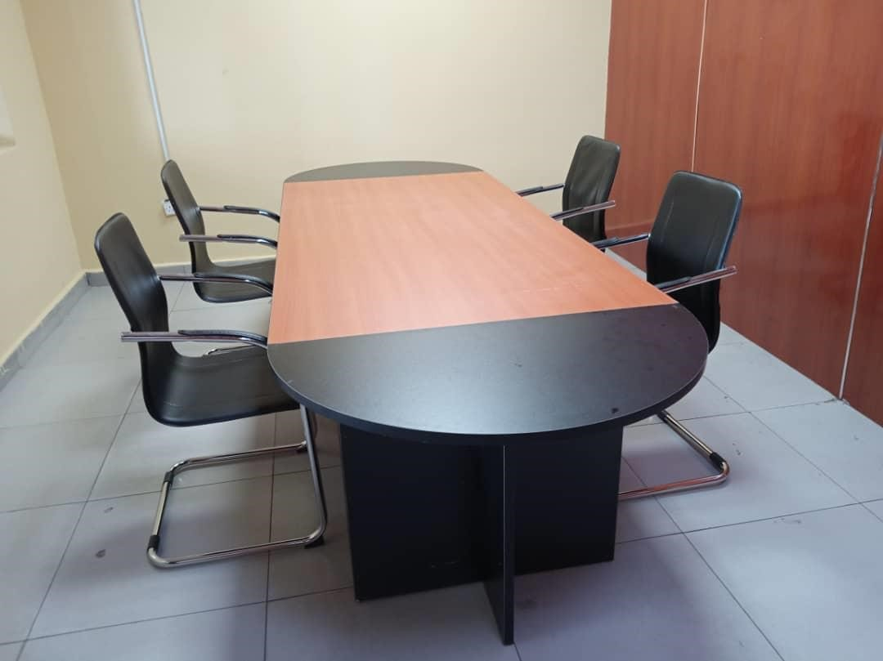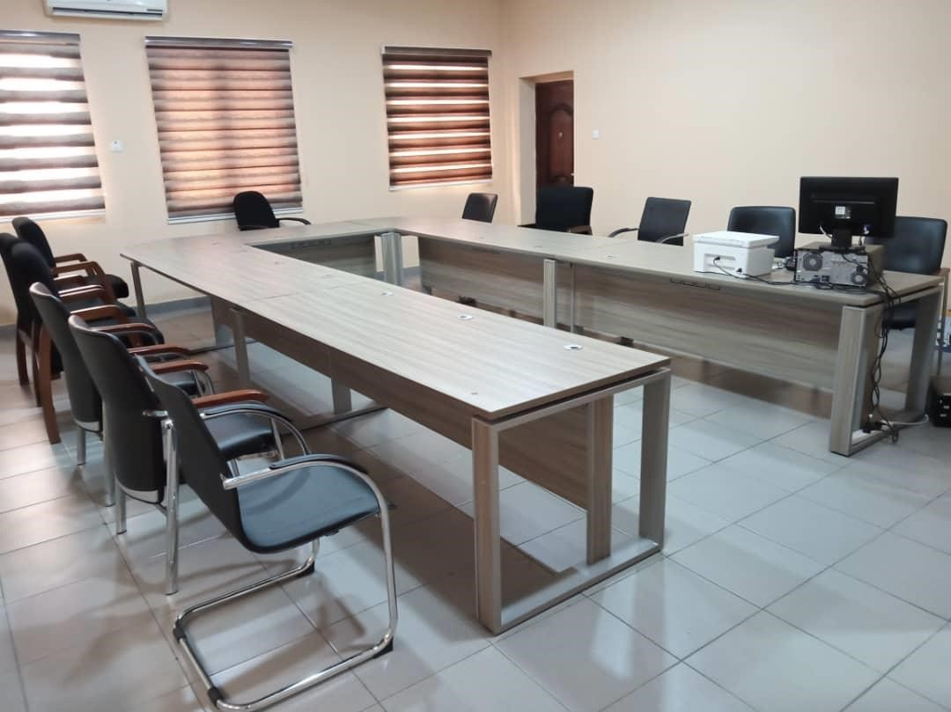

A matter may be initiated at the RSMDC in either of three ways:

1. Walk-Ins: Any party to a dispute may initiate a Mediation, Arbitration or any other ADR process by completing and filing the requisite process initiating forms at the RSMDC.
2. Court Referrals: The Presiding Judge or Magistrate in a matter already in litigation (Court) or a judge in the course of a Pre-Trial conference may, in appropriate circumstance, refer parties to the Centre.
3. Direct Interventions: The RSMDC, in circumstances where public interest or the interest of the disputing parties so demand, may approach parties and obtain their consent with a view to assisting in the resolution of their dispute.

**THE ADR PROCESS**

1. **Stage 1** is the stage at which the disputants complete and file the RSMDC Request Form (Form 1) along with supporting documents. The Request Form (Form 1) is filled and filed at the RSMDC by the initiating party attaching the Brief Statement of Issues (4 copies). Within 7 days of filing Form 1, Notice of Referral is sent to the other party by the Deputy Director along with the Submission Form (Form 2), Memorandum to Parties (Form 3) and a copy of the Applicant’s Statement of Issues.

Within 7days, the Responding party is to return the duly completed Submission Form to the RSMDC, indicating submission to the ADR process and certification to the receipt and understanding of the Memorandum to Parties. 4 copies of the Respondent’s Brief Statement of Issues are to be attached.

1. **Stage 2** is where the ADR Registrar confirms receipt of the Brief Statement of Issues between parties. Thereafter, intake screening is carried out and a pre-session meeting may be convened with the Dispute Resolution Officer [DRO]. Here, the process is explained, issues clarified, interest identified and an ADR process agreed upon.

At this stage, the DRO provides the parties with Confirmation of Attendance Form [Form 4] and Confidentiality Agreement [Form 5], which are to be filled and signed by the parties. Also the bio-data of the recommended neutrals (Mediators, Early Neutral Evaluators or Arbitrators etc.) are given to the parties so that they can select the neutral of their choice.

1. **Stage 3** is where an ADR session is scheduled tentatively, and a Notice sent to the Mediator, Early Neutral Evaluator or Arbitrator along with the Disclosure Form. The Mediator or Arbitrator is to reply to the Notice within 7 days of accepting or declining his nomination with the duly completed Disclosure Form returned to the Deputy Director (Registrar) of the RSMDC. Mediation, Early Neutral Evaluation or Arbitration Pre-session is then convened.
2. **Stage 4** is the stage at which the ADR intervention commences proper and the disputants fully engage in the process towards the resolution of the dispute.
3. **Stage 5** is the closure/final stage of the process where there is a Settlement, an Award, a Non-binding Opinion or a transition to other Hybrid processes.

**ENFORCEMENT**

At the RSMDC, settlements are enforceable. A Settlement Agreement which is duly signed by the parties when endorsed and adopted by an ADR Judge, is deemed to be enforceable as a Judgment of the Court of Rivers State. Referred cases when settled through Mediation may also be returned with Terms of Settlement for adoption as Consent Judgment. Where there is an Award, it shall be transmitted to a Court for Recognition and Enforcement Order.

**FREQUENTLY ASKED QUESTIONS**

**What Kinds of Cases do the RSMDC Handle?**

The RSMDC provides parties and their Counsel with effective alternatives for resolving civil matters of Commercial, Landlord and Tenant, Employment, Banking, Maritime, Energy, Defamation & Libel, Family or Business disputes.

In criminal causes, by leave of court, the RSMDC can assist the prosecutor and defendant, through mediation, to reach amicable settlement of an offence under Section 29 of the Rivers State High Court Law 2001 or Section 41 of the Rivers State Magistrates Courts Law, No. 2 of 2004. Furthermore, by leave of court, RSMDC can also assist the prosecutor and defendant in a plea bargain through assisted negotiation (Mediation). The RSMDC also assists in Restorative Justice through Victim-Offender Mediation. It provides the parties with the advantages of a neutral environment, and a neutral third party intervener bound by a Code of Conduct for Neutrals.

**What are the Alternative Processes Offered?**

The alternative processes to litigation which the RSMDC offers in resolving disputes are Mediation, Conciliation, Arbitration, Early Neutral Evaluation, Negotiation, Conciliation and other ADR processes.

**How Much Does It Cost?**

In an attempt to maintain a standard of service rooted in confidentiality, impartiality, independence, quality and professionalism whilst ensuring less expense to the parties, the RSMDC has developed non-commercial and highly subsidized fees rates to meet with its goals. The specific details of these fees are contained in the RSMDC Fees Schedules which may change from time to time, but with adequate notice to the public. The RSMDC also provides Fee Review/Pro Bono Services when appropriate to ensure that there is Access to Justice for all.

**Who Pays for the Session(s)?**

The parties share the fees and expenses in equal parts except when otherwise agreed by the parties and by the provision of any relevant law.

**What is Mediation?**

Mediation is a voluntary and flexible dispute resolution process in which an impartial neutral third party (the Mediator) facilitates negotiations between the parties to assist them reach a settlement. The hallmark of Mediation is its capacity to expand traditional settlement discussions and broaden resolution options by going beyond the legal issues in controversy, for an amicable resolution.

**What is Arbitration?**

Arbitration is a private adjudicatory dispute resolution process in which one or more Arbitrators issue a binding award on the merits after an expedited adversarial hearing.

**What is Early Neutral Evaluation?**

Early Neutral Evaluation is an ADR process that brings all parties and their counsel together early in the pre-trial period, to present summaries of their cases and receive a non-binding assessment by a retired Judge or an experienced lawyer or neutral with the subject-matter experience. The Evaluator also provides case planning guidance and if requested, settlement assistance.

**What are Hybrid Processes?**

In Mediation-Arbitration (Med-Arb) the initial step is Mediation. If the case does not settle, the matter proceeds to Arbitration. Whereas in Arbitration-Mediation (Arb-Med), the matter starts with Arbitration. The Arbitrator does not deliver the award, but seals it in an envelope while the case proceeds to Mediation. If no agreement is reached, the Arbitrator then delivers the award.

**What is the Effect of Case Disposition at the RSMDC?**

At the RSMDC, cases are disposed of quickly and efficiently in a conducive environment, while the parties save time, cost, preserve their business and other relationships, as well as participate in the dispute resolution process.

**Will suggesting ADR to the other party not be construed as a sign of weakness or a perception that I have a bad case?**

Suggesting ADR is neither a sign of weakness nor an indication of a bad case. On the contrary, it is an indication that counsel has an understanding of the benefits of ADR and the 21st century approach to dispute resolution.

**If we do not reach a settlement at Mediation, what do I do?**

If a party fails to reach a settlement at Mediation, they may opt to explore other ADR doors like Early Neutral Evaluation or Arbitration, as appropriate.

**What is the role of the Court in referring disputes to the RSMDC?**

Section 18 of the RSMDC Law provides that every Judge of the High Court of Rivers State and Magistrate shall further the cause of ADR and give effect to the objectives of the RSMDC by controlling and managing proceedings in Court and issuing Orders which shall encourage the adoption of ADR methods in dispute resolution including the mandatory referral of parties to explore settlement at the RSMDC. Section 18 (1) (e) of the RSMDC Law specifically provides for mandatory referral.

**What is the role of the ADR Judge?**

The ADR Judge is empowered to require the attendance before him of the defaulting party who refuses or neglects to submit to ADR. He may make Directives or give Orders as he may deem fit in the circumstances towards giving effect to the overriding objectives of the RSMDC. The ADR Judge is also empowered to adopt Settlement Agreements to make them enforceable as Judgments of Court. See Section 17 of the RSMDC Law.

**What is the role of Counsel?**

Lawyers are an integral part of the RSMDC programme and have the responsibility to the Court, the RSMDC and the legal profession to give due consideration and support to suggestions, Orders and Directives from the Court for an amicable settlement or referral of on-going matters to the RSMDC. Pursuant to Rule 15 (3)(d) of the Rules of Professional Conduct for Legal Practitioners 2007, a lawyer is under legal obligation to properly inform his client about all the dispute resolution doors to resolve his client’s case.

**What is the role of Parties?**

Disputing parties have a responsibility to the RSMDC to cooperate with RSMDC officials in the administration of their dispute and to comply with the Directives and Orders of Court for the adoption of ADR procedures for resolving their claims or issues.

**Will a referral of my case to the RSMDC for ADR deprive me of my Constitutional right to litigate my case in a Court of law?**

No. A referral to ADR does not deprive you of your day in Court. What the referral Judge or Magistrate requires of you is to make a good-faith attempt to resolve the dispute at the RSMDC within the time frame specified, and if that fails, you are required to return to the Court for trial.

**To represent a client in ADR do Lawyers require any training?**

To be effective in ADR and to demonstrate appreciable professionalism as a client representative, training is desirable. The acquisition of Mediation Advocacy Skills for instance will enable a lawyer bring value to the negotiation table and get good settlement deals for his client. Mediation Advocacy training will be organized by the RSMDC for all lawyers from time to time and Mediation Skills Training will be available for those who wish to train as interveners in the Mediation process as Mediators. Similar training programmes shall be conducted on Arbitration.

**Will the referral of cases in litigation deprive the lawyer of income?**

The use of ADR and the referral of cases to ADR will not deprive the lawyer of his income. The value preposition here is that every lawyer who wishes to embrace this new global trend must learn how to carve out a new income stream from a well-articulated ADR practice which complements the already established litigation practice. This transactional layering also requires a proactive billing structure. Clients should pay for the benefits they receive from this service. This position is also reinforced by the RSMDC. For matters referred from Court, billing of clients must address the possibility of a referral and make ample provision for payment(s) in such a case.

**Is it true that adopting an appropriate dispute resolution clause in drafting contracts can affect my client adversely in the event of a dispute?**

Proper consideration should be given to the use of dispute resolution clauses in contracts. The use of three-tiered ADR clauses is the recommended Dispute Resolution tool for modern day Agreements, thus:

1. In the event of any dispute, difference or claim arising out of or in connection with this agreement, the parties shall meet in good faith, within a month of the knowledge of the dispute, for negotiations in an effort to resolve the dispute amicably.

2. If the dispute is not settled by Negotiation within 14 days of commencement of such negotiations or within a longer period as agreed to by the parties, the dispute, difference or claim shall be referred to the Rivers State Multi-Door Courthouse for Mediation.

3. If the parties fail to reach a settlement via Mediation within 14 days, the matter shall be settled by Arbitration in accordance with the Arbitration and Conciliation Act, Cap A18, Laws of the Federation of Nigeria (LFN), 2004 or the Rivers State Arbitration Law, No. 10 of 2019. The Arbitration shall be conducted by a sole Arbitrator to be appointed by the RSMDC or such other office or body as agreed by the parties; Provided, Always that the parties may by mutual agreement extend the period of time specified in their agreement or opt for the appointment of three arbitrators as against a sole Arbitrator if considered desirable.

**THE RIVERS STATE MULTI-DOOR COURTHOUSE (RSMDC)**

**-THE ALTERNATIVE DISPUTE RESOLUTION (ADR) CENTRE-**

**IST FLOOR, BLOCK E, HIGH COURT COMPLEX,**

**PORT HARCOURT.**

For further enquiries:

**Tel:** 07064203754 08036700226 0703527503

08109889970 08033136839 08037982277

**Email:** riv.multidoorcourthouse@gmail.com